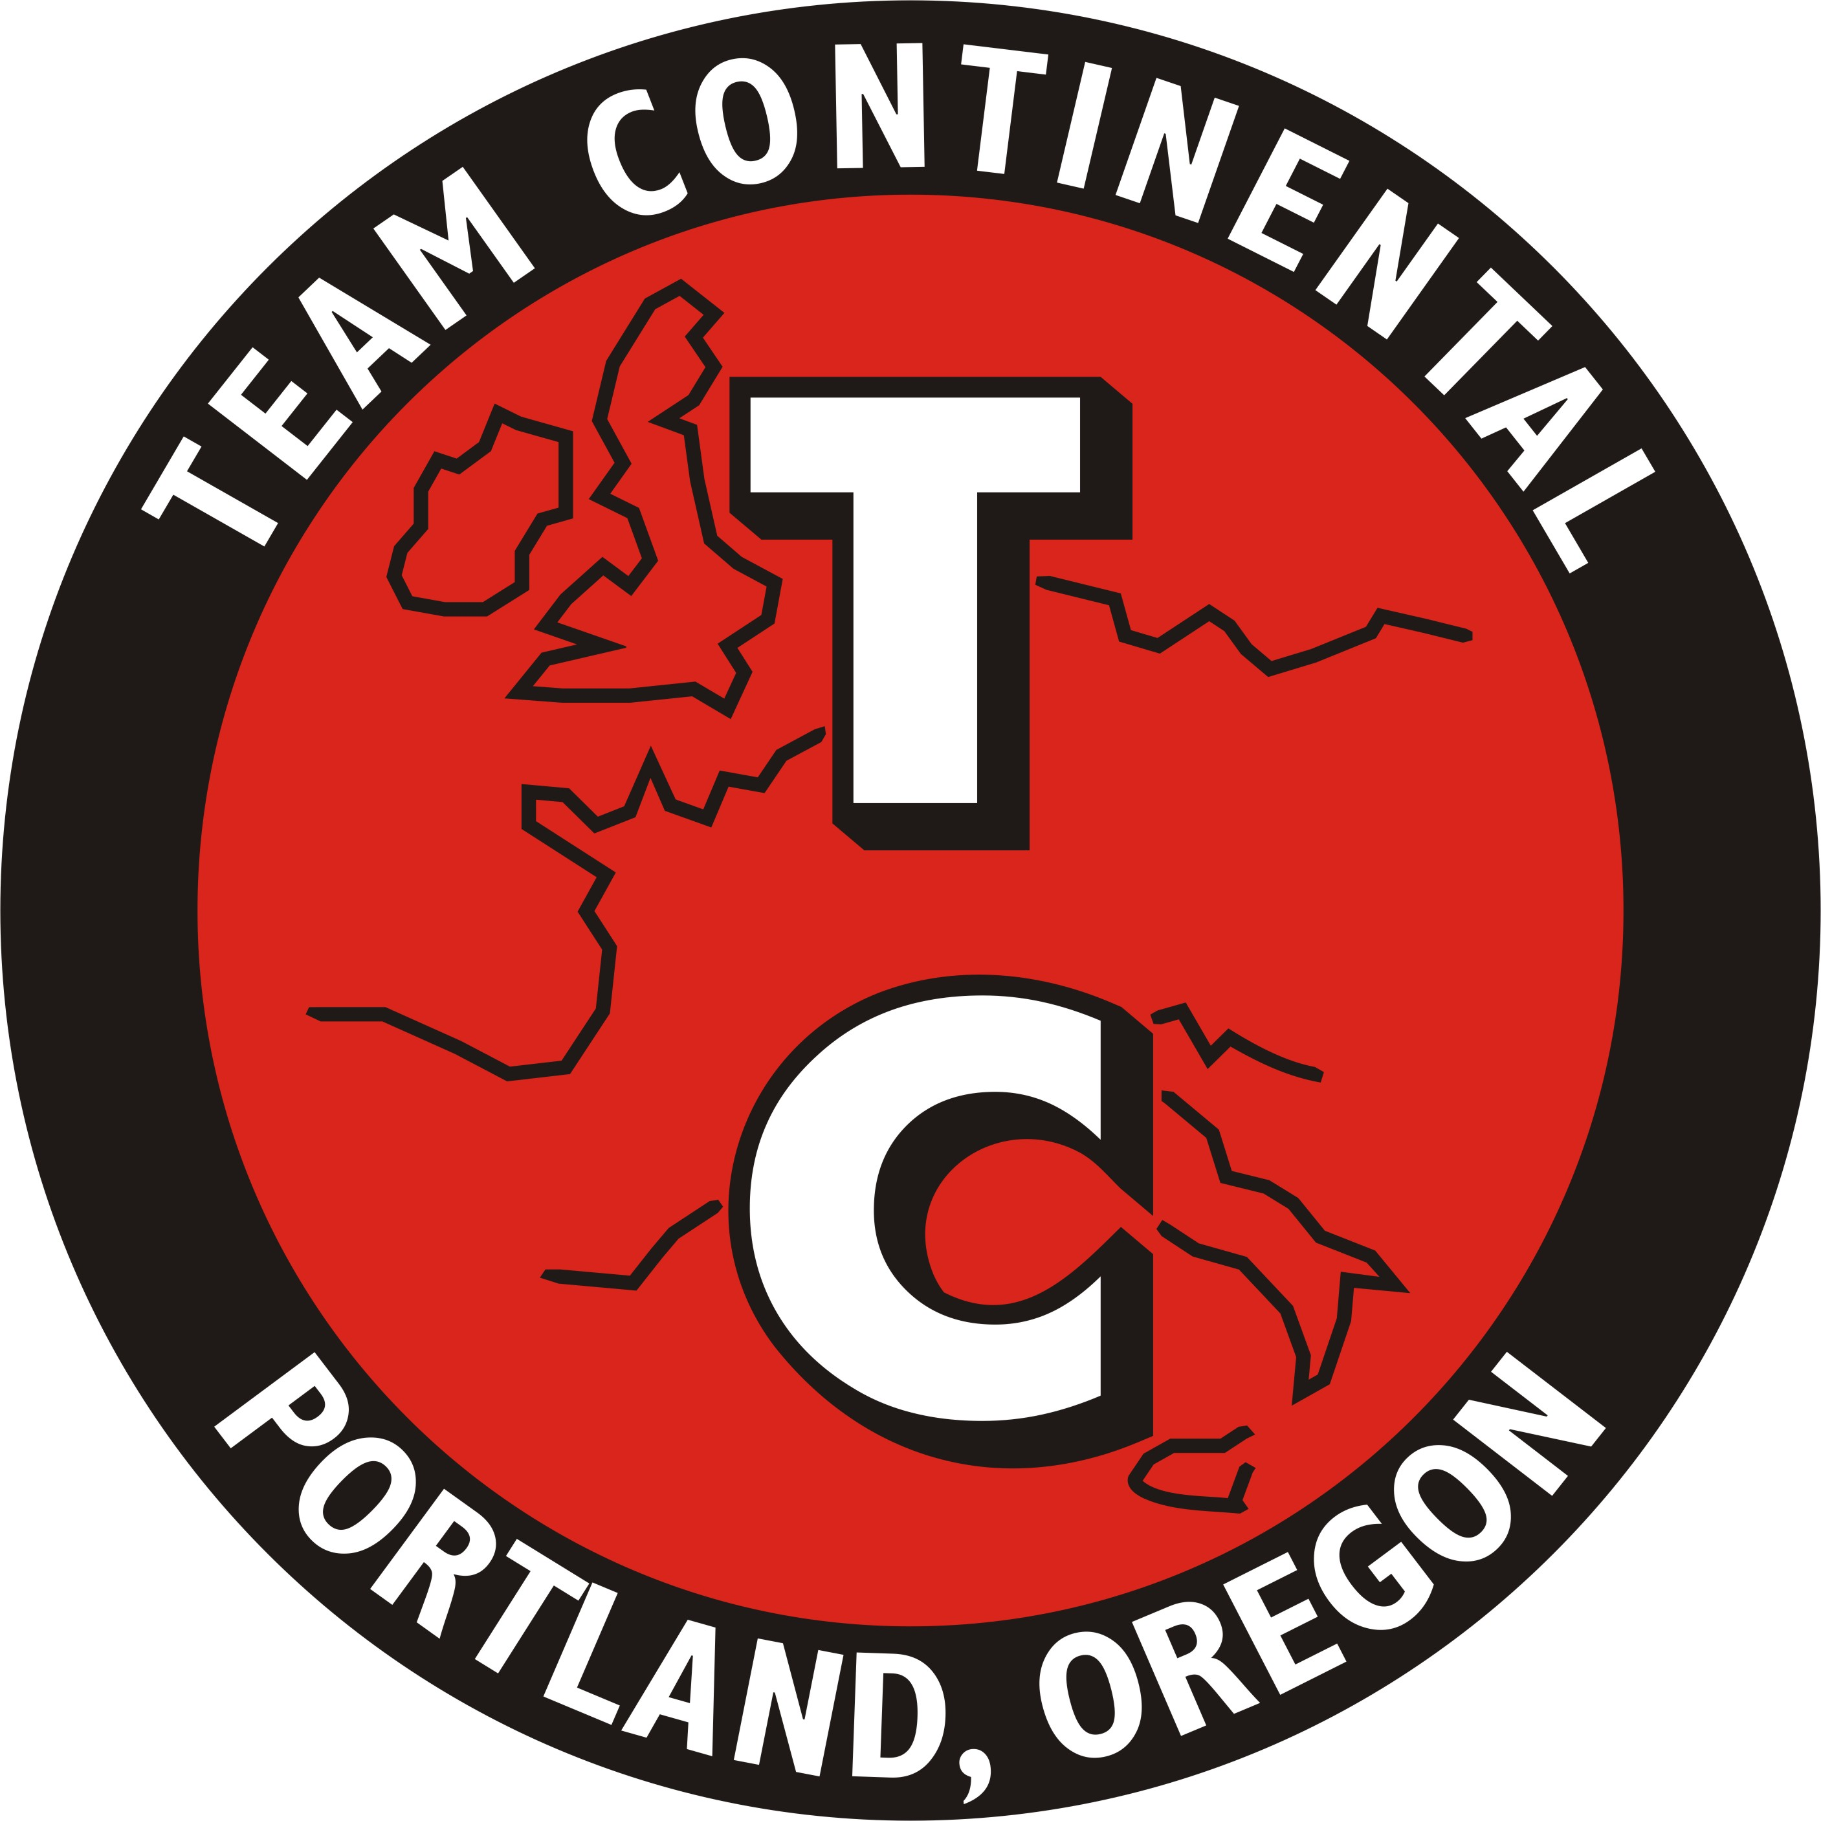
TC Rule Change Meeting #1

At the Wednesday July 16th TC general meeting I called for ICSCC rule change proposals from the TC membership.

I would now like to invite TC members to attend the first rule change meeting for 2014 to discuss your proposals and hone them before they are presented to the Race Steward.

The meeting will be held at Columbia River Brewing
1728 NE 40th Ave Portland OR., On Wednesday August 27th 2014 at 7PM.

All TC members that plan to attend: Please RSVP to cboard@teamcontinental.com or 503-706-4135 so that I can finalize the restaurant reservations.

Thank You,
Peter Linssen
Team Continental Contest Board Representative

