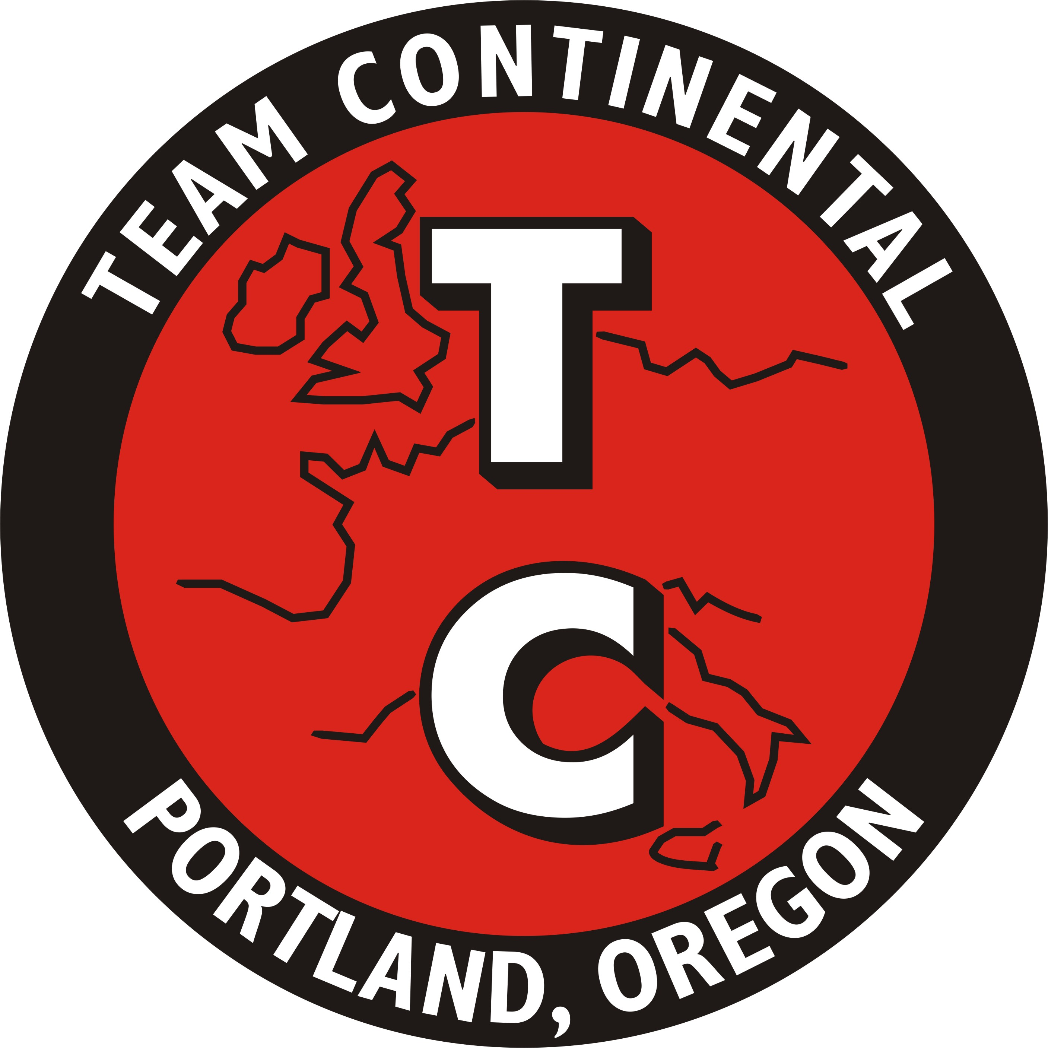
TC Rule Change
Vote
Meeting

I would like to invite all TC licensed drivers to attend TC’s ICSCC rule change vote meeting for 2014

The meeting will be held at Columbia River Brewing
1728 NE 40th Ave Portland OR., On Monday November 3rd 2014 at 7PM.

All TC members that plan to attend: Please RSVP to cboard@teamcontinental.com or 503-706-4135 so that I can finalize the restaurant reservations.

Thank You,
Peter Linssen
Team Continental Contest Board Representative

